
Sukkur Institute of Business Administration University
Department of Computer Science

Programming Fundamentals
BS – I (CS/AI/SE) Fall-2024

Lab # 12: Functions and Pointers

Objectives

Objective of Lab No. 12:
After performing this lab, students will be able to

- Understand call by value and call by reference
- Use pointers
- Use recursive functions

Example 1: C++ Pointers and Arrays
// C++ Program to display address of each element of an array

#include <iostream> using namespace std;

int main()
{
float arr[3];

// declare pointer variable float *ptr;

cout << "Displaying address using arrays: " << endl;

// use for loop to print addresses of all array elements for (int i = 0; i < 3; ++i)
{
cout << "&arr[" << i << "] = " << &arr[i] << endl;
}

// ptr = &arr[0] ptr = arr;

cout<<"\nDisplaying address using pointers: "<< endl;

// use for loop to print addresses of all array elements
// using pointer notation for (int i = 0; i < 3; ++i)
{
cout << "ptr + " << i << " = "<< ptr + i << endl;
}

return 0;
}

Output

Displaying address using arrays: &arr[0] = 0x61fef0
&arr[1] = 0x61fef4 &arr[2] = 0x61fef8

Displaying address using pointers: ptr + 0 = 0x61fef0
ptr + 1 = 0x61fef4

ptr + 2 = 0x61fef8

In the above program, we first simply printed the addresses of the array elements without using the pointer variable ptr.

Then, we used the pointer ptr to point to the address of a[0], ptr + 1 to point to the address of a[1], and so on.

In most contexts, array names decay to pointers. In simple words, array names are converted to pointers. That's the reason why we can use pointers to access elements of arrays.

However, we should remember that pointers and arrays are not the same.

Example 2: Array name used as pointer
// C++ Program to insert and display data entered by using pointer notation.

#include <iostream> using namespace std;

int main() {
float arr[5];

// Insert data using pointer notation cout << "Enter 5 numbers: ";
for (int i = 0; i < 5; ++i) {

// store input number in arr[i] cin >> *(arr + i) ;

}

// Display data using pointer notation cout << "Displaying data: " << endl; for (int i = 0; i < 5; ++i) {

// display value of arr[i] cout << *(arr + i) << endl ;

}

return 0;
}

Output

Enter 5 numbers: 2.5
3.5
4.5
5
2
Displaying data:
2.5
3.5
4.5
5
2

Here,
We first used the pointer notation to store the numbers entered by the user into the array arr.

cin >> *(arr + i) ;
This code is equivalent to the code below:

cin >> arr[i];

Notice that we haven't declared a separate pointer variable, but rather we are using the array name arr for the pointer notation.

As we already know, the array name arr points to the first element of the array. So, we can think of arr as acting like a pointer.

Similarly, we then used for loop to display the values of arr using pointer notation. cout << *(arr + i) << endl ;

This code is equivalent to cout << arr[i] << endl ;

Passing value vs. passing reference as function argument in C++
C++ Pass by Value vs. Pass by Reference
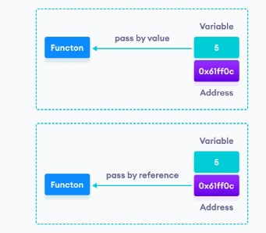

Practice Task No. 1:
Write a swap function with (a) pass by value, (b) pass by reference, and (c) pass by pointers. (a)
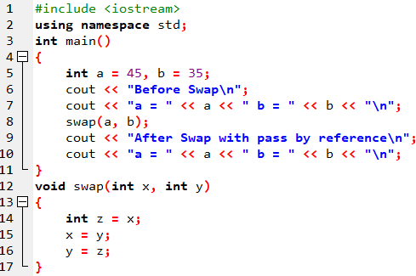

(b)
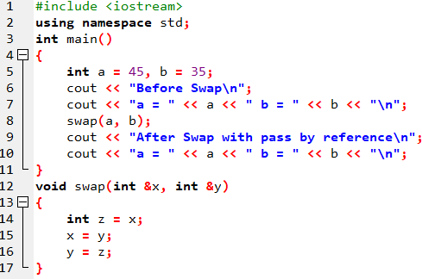

(c)
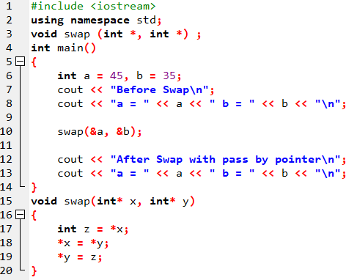

Difference in Reference variable and pointer variable
References are generally implemented using pointers. A reference is same object, just with a different name and reference must refer to an object. Since references can’t be NULL, they are safer to use.
- A pointer can be re-assigned while reference can not, and must be assigned at initialization only.
- Pointer can be assigned NULL directly, whereas reference cannot.
- Pointers can iterate over an array, we can use ++ to go to the next item that a pointer is pointing to.
- A pointer is a variable that holds a memory address. A reference has the same memory address as the item it references.
- A pointer to a class/struct uses ‘->'(arrow operator) to access it’s members whereas a reference uses a ‘.'(dot operator)
- A pointer needs to be dereferenced with * to access the memory location it points to, whereas a reference can be used directly.

Practice Task No. 2:
Write a following recursive function to generate tower of Hanoi puzzle. void towerOfHanoi(int n, char from_rod, char to_rod, char aux_rod) ;

Tower of Hanoi is a mathematical puzzle where we have three rods and n disks. The objective of the puzzle is to move the entire stack to another rod, obeying the following simple rules:

- Only one disk can be moved at a time.
- Each move consists of taking the upper disk from one of the stacks and placing it on top of another stack i.e. a disk can only be moved if it is the uppermost disk on a stack.
- No disk may be placed on top of a smaller disk.
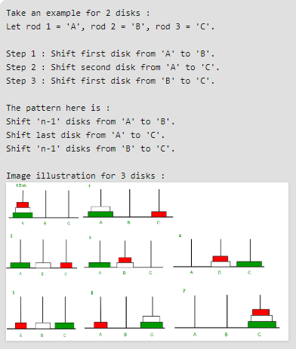

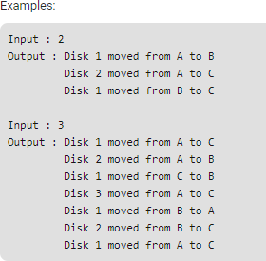

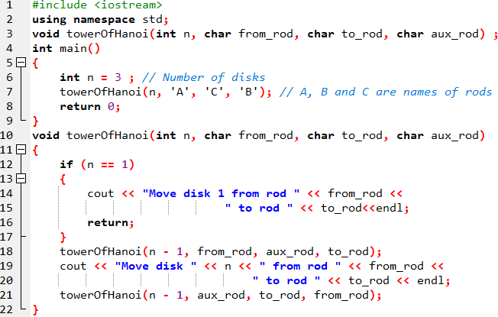

Exercises
  - Write a C++ program that creates an integer array of size 10.
Then, get the array values as input from the user but save them in the array using a pointer. Then, print those values using the pointer
Then, ask the user to search any value and perform a search operation using the pointer

  - Initialize an integer array of 5 elements. Then, print values of all elements along with their addresses using pointers.

String Manipulation with Pointers
Write a function that takes a string (array of characters) and reverses it using pointers.

  - Write a following recursive function to generate fibnocii series. int Fib (int num) ;

  - Write a following recursive function to generate factorial of given number. int Factorial (int num) ;

